Oil Contamination Treatment Solution
For Waste Water Plant

With the development of society, the oil contamination discharged from civil and industrial industry goes steadily up, so it prevents normal operating of the waste water plant. Many experts in waste water treatment industry declare that once oil contamination flow to the waste water plant, the flocculation and precipitation treatment way will fail, we have to employ the physical absorbing way to remove it, and then the treated water will flow to the purification process so that the discharge water to be in compliance with environmental laws and regulations or internal ISO 14001 Objectives and Targets. As per the many years of experiences of oil contamination treatment of waste water plant, we provide the following solution.
Products
- FG oil absorbent boom Model：FG-XTL-Y (200mm*1000mm)
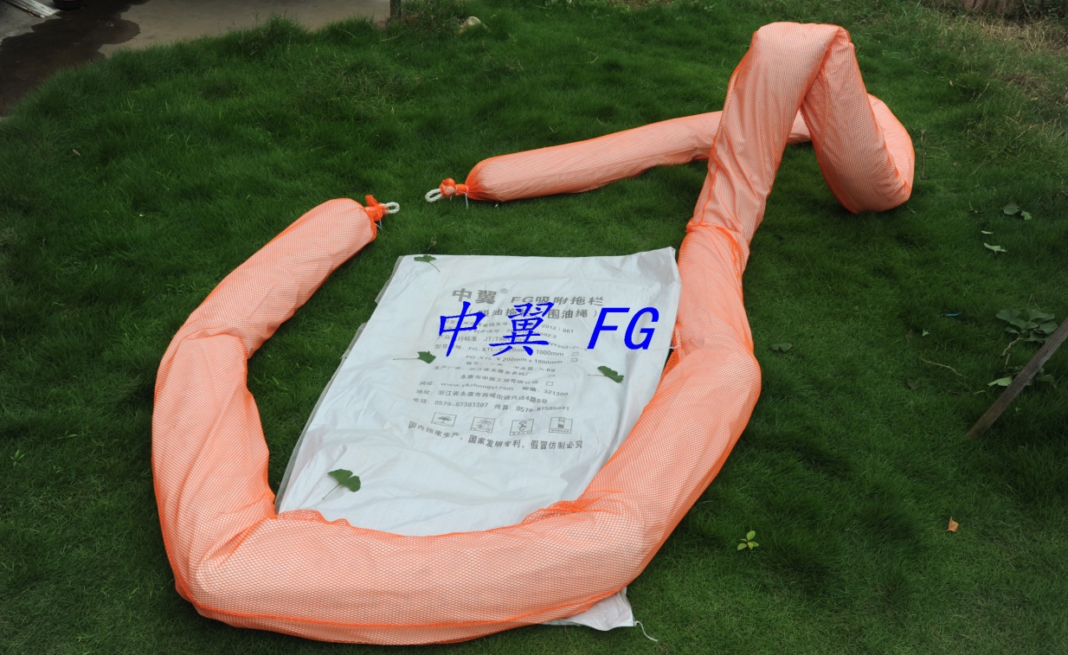

- FG oil absorbent granule Model：FG1000
- FG oil absorbent pad Model：FG6090（600mm×900mm）
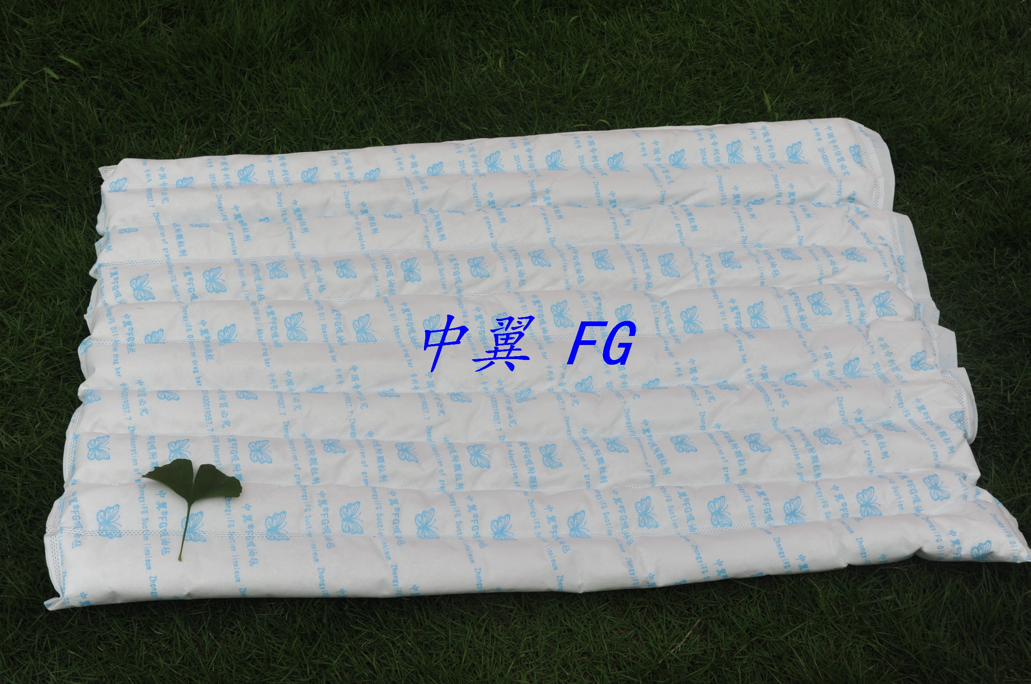
- Fishing gear
- Recycled bag
How to use?
1. Watch the waste water inlet. The oil contamination discharged from civil and industrial industry indicates black brown.
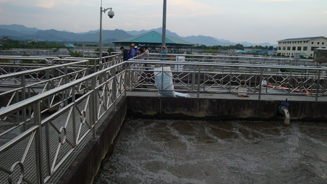
2. The FG oil absorbent boom is placed on the water surface of waste water pool to prevent the oil contamination to flow to purification pool.
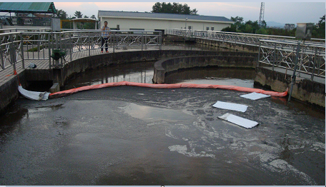
3. The FG oil absorbent granule is thrown to the waste water inlet. The worker salvage the FG oil absorbent granule by the fishing gear after it is saturated and indicates black brown. The used granule is put into the recycled bag and can be as fuel.
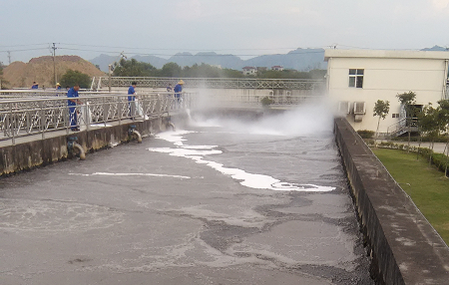
4. After treatment, people cannot see oil contamination on the water surface with their naked eyes.
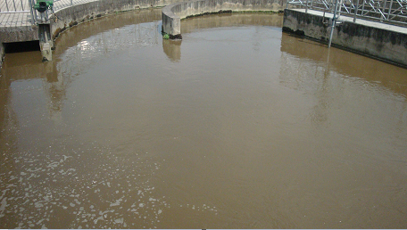
5. The FG oil absorbent boom and FG oil absorbent pad are usually placed on the water surface of waste water pool to intercept and absorb oil contamination so that the further process treatment is easy.

